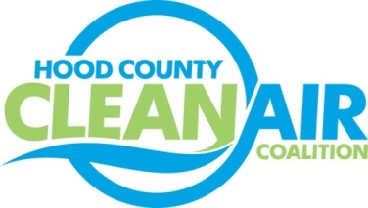
Meeting: Thursday, September 7, 2017
Neely House
304 East Rucker Street, Granbury, Texas 76048
8:30-10:00 a.m.

Agenda

- Call Meeting to Order
- EPA Updates – Randy Pitre, EPA
- Local Updates – Michelle McKenzie
  - Review of August Meeting Summary
  - Reports
    - August Ozone Update
    - EPA Webinar NAAQS Implementation
  - Review of Projects
    - Monthly Budget Review for July
    - Status of Projects FY 16/17
  - Loss of Rider 7 Funding
  - Regional Director Letters Follow up
- Regional Updates – Michelle McKenzie
  - Air Quality Funding Opportunities: www.nctcog.org/aqfunding
  - Drive Electric Week: www.driveelectricdfw.org
  - Webinar September 26: LED Streetlight Retrofit: www.nctcog.org/trans/air/energy.asp
  - EPA Withdrawal of One-Year Extension for 2015 Ozone Standard Designations; www.nctcog.org/trans/committees/sttc/2017/08Aug/Ref.Itm_12.5.sttc082517.pdf
  - Southern Transportation Air Quality Summit, August 29-30; summary of presentations: www.nctcog.org/trans/air/Conferences/STAQS2017-DFW.asp
  - Air North Texas Progress Reports Due and Conference Call Rescheduled
- Other Discussion
- Adjourn

